**Chapter-5**

System Analysis

**5.1 Introduction  
5.2 Analysis Model  
5.3 Requirement Specification  
5.4 Feasibility Study  
5.5 Life Cycle Model  
5.6 Effort Distribution Diagram  
5.7 Task Dependency Diagram  
5.8 Timeline Chart**

**5. System Analysis**

**5.1 Introduction**

After analyzing the requirements of the task to be performed, the next step is to analyze the problem and understand its context. The first activity in the phase is studying the existing system and other is to understand the requirements and domain of the system. Both the activities are equally important, but the first activity serves as a basis of giving the functional specifications and then successful design of the proposed system. Understanding the properties and requirements of a new system is more requires creative thinking and understanding of existing running system is also difficult, improper understanding of present system can lead diversion from solution.

**5.2 Analysis Model**

Here the linear ordering of these activities is of one phase is the input of other phase. The output of each phase is to be consistent with the overall requirement of the system. Some of the qualities of spiral model are also incorporated like after the people concerned with the project review completion of the phase the work done.  
The model that is basically being followed is the WATER FALL MODEL, which states  
that the phases are organized in a linear order. First of all, the feasibility study is done. Once that part is over the requirement analysis and project planning begins. The design starts after the requirement analysis is complete and the coding begins after the design is complete. Once the programming is completed, the testing is done. In this model the sequence of activities performed in a software development project are:

* Requirement Analysis
* Project Planning
* System design
* Detail design
* Coding
* Unit testing
* System integration & testing

Here the linear ordering of these activities is one phase is the input of other phase. The output of each phase is to be consistent with the overall requirement of the system. Some of the qualities of spiral model are also incorporated like after the people c of the phase the work done.

**WATER FALL MODEL** was being chosen because all requirements were known beforehand and the objective of our software development is the computerization / automation of an already existing manual working system.

**5.3 Requirement Specification**

Before building an elegant application, best way to identify basic needs and  
functionality is to visit websites relevant to that specific area addressed by proposed application. For gathering basic needs and functionalities, we had meeting with organization personal to understand requires functionalities also noted down some useful feature to be included. We also referred some articles related to application to understand various functionalities:

* Requirement gathering for project **“School Management System”** initiated by the study of a past few projects.
* Some of the very experienced people like Mr. A. H. Shohel Ahamed from Shanto-Mariam University of Creative Technology also helped in the process of requirements gathering.
* The requirements thus gathered ware thereby accomplished the part of requirements gathering and analyses.
* We also taken guidance from our university faculties to clear about  
  requirement analyses.
* We held several meetings with our project guide to decide the process  
  model and basic system architecture.
* The current system is that satisfied all users requirement.
* Therefore it is very important to analyzed existing system which is provide base for the development and proposed system.

**5.4 Feasibility Study** Depending on the results of the initial investigation the survey is now expanded to a more detailed feasibility study. ***“FEASIBILITY STUDY”*** is a test of system proposal according to its workability, impact of the organization, ability to meet needs and effective use of the resources. It focuses on these major questions:

* What are the user’s demonstrable needs and how does a system Meet them?
* What resources are available for given candidate system?
* What are the likely impacts of the candidate system on the organization?
* Whether it is worth to solve the problem?

During feasibility analysis for this project, interest is to be considered.

* **Steps in Feasibility Analysis:**
* Form a project team and appoint a project leader.
* Prepare system flowcharts.
* Enumerate potential proposed system.
* Define and identify characteristics of proposed system.
* Select the best-proposed system.
* Determine and evaluate performance and cost effective of each proposed system.
* Weight system performance and cost data.
* Prepare and report final project directive to management.

**Operational Feasibility**  
**5.4 Feasibility Study**The new system can be beneficial only if it satisfies the organization requirements; in such a way that resource utilization and optimum outcome is justified. A new system should not only be robust but should also be able to work simultaneously with other systems. Operational feasibility means that new system should not affect any existing system during the development phase or even in the implementation phase. Following are some points underlying the operational feasibility of the system- As the development proceeded many doubts got cleared out.

* Our project guide **Mr. A. H. Shohel Ahamed** and check for the operational feasibility of the system.
* Efforts were made to optimize the human efforts in data storage, retrieval, security and presentation.
* The proposed system made best efforts in achieving necessary function and performance, as required by the user and keeping in mind some infrastructure constraints.

**Technical Feasibility**

Developers of computer based systems are optimists by nature. During an evaluation of technical feasibility, a cynical, if not pessimistic, attitude should prevail. Misjudgment at this stage can be disastrous.

* **The technical issues during the analysis generated were….**
* What are the hardware and software requirements for the proposed system was the first major issue of the discussion.
* Windows XP operating system was used.
* All hardware support required for the development of the system.
* So, technically the development of the system.

**Economical Feasibility**

Among the most important issues in feasibility study is ‘cost benefit analysis’, an assessment of the economic justification for a Computer based system project. The cost involved in designing and developing a system should be a good investment for the organization. The financial benefits must be justified by the cost.

**The financial and economic issues raised during preliminary investigation are as follows…** 

* Cost of conducting system study and system development is in house.
* There is no extra cost of hardware, as it already exists sufficiently.

Thus, looking towards the advantages constraints, it seems that it is feasible to d resources.

When a project is undertaken its economic and financial gains and losses have to be considered i.e. whether the organization can support the cost incurred during the development of the project. This is known as economic feasibility. The tangible and intangible benefits were considered. Taking these factors into consideration a Cost Benefit Analysis was carried out for evaluating the proposed system.

* **The evaluation was carried out under the following two heads:** 
* **Hardware Cost:**

The organization already possesses the required hardware and software for the system, so no additional cost will be incurred in implementing the system.

* **Manpower Cost:**

The proposed system is user friendly and does not require much knowledge of computers. Thus, there is no requirement of highly qualified staff in computers requiring big amounts of salaries.  
Thus no extra expenditure is required for manpower. Therefore, the system is financially feasible.

* **Maintenance Cost:**

The proposed system is user Maintenance cost machinery cost, employee cost and other cost are including in company costs Maintenance cost etc...

**5.5 Life Cycle Model**

* **Types of Life Cycle model:** 
* Prototype Model
* Waterfall Model
* Iterative Enhancement Model
* The Spiral Model
* Dynamic System Development Model

**Prototype Model**

The goal of prototyping based development is to counter the first two limitations of the waterfall model discussed earlier. requirements before a design or coding can proceed, a throwaway prototype is built to understand the requirements. This prototype is developed based on the currently known requirements. Development of the testing. But each of these phases is not done very formally or thoroughly. By using this prototype, the client can get an "actual feel" of the system, since the interactions with prototype can enable the client to better understand the requirements of the desired system.

**Iterative Enhancement Model**

The iterative enhancement life cycle model counters the third limitation of the waterfall model and tries to combine the benefits of both model. The basic idea is that the software should be developed in increments, where each increment adds some functional capability to the system until the full system is implemented. At each step extensions and design modifications can be made. A of this approach is that it can result in better testing, since testing each increment is likely to be easier than testing entire system like in the waterfall model. Furthermore, as in prototyping, the increments provide feedback to the client which is useful for determining the final requirements of the system.

**Spiral Model**  
This is a recent model that has been proposed by Boehm. As the name suggests, the activities in this model can be organized like radial dimension represents the cumulative cost incurred in accomplishing the steps dome so far and the angular dimension represents the progress made in completing each cycle of the spiral. The structure of the spiral model is shown in the figure given below:

Each cycle in the spiral begins with the identification of objectives for that cycle and the different alternatives are possible for achieving the objectives and the imposed constraints.

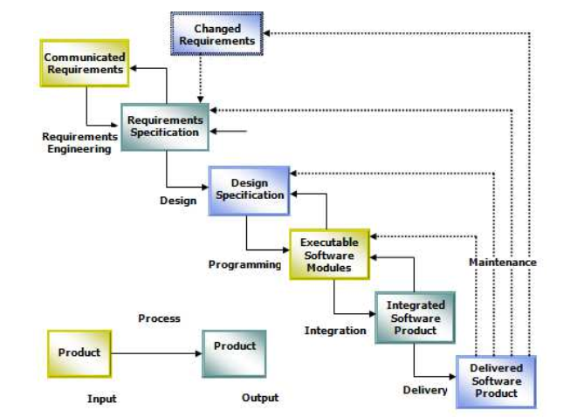**Waterfall Model**We have followed “Water Fall Model” for software engineering. This method suggests a systematic, sequential approach to software development that being at the system level and progress through analysis, design, coding, testing and maintenance. This model is also called “**Linear Sequential Model”** as one has to follow all the above five stages sequentially. Also called the **“Classic Life Cycle”** is the oldest and the most widely used paradigm for Software Engineering.

**Fig: Water Fall Model**

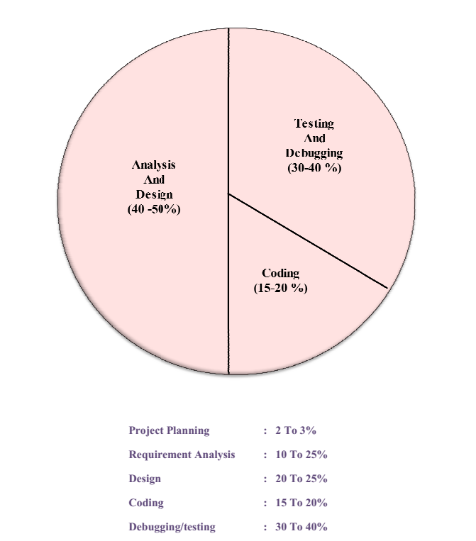**5.6 Effort Distribution Diagram**

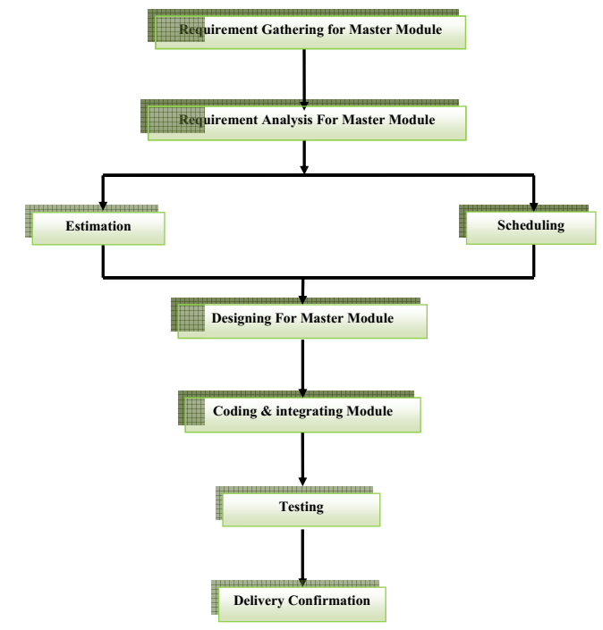**5.7 Task Dependency Diagram**

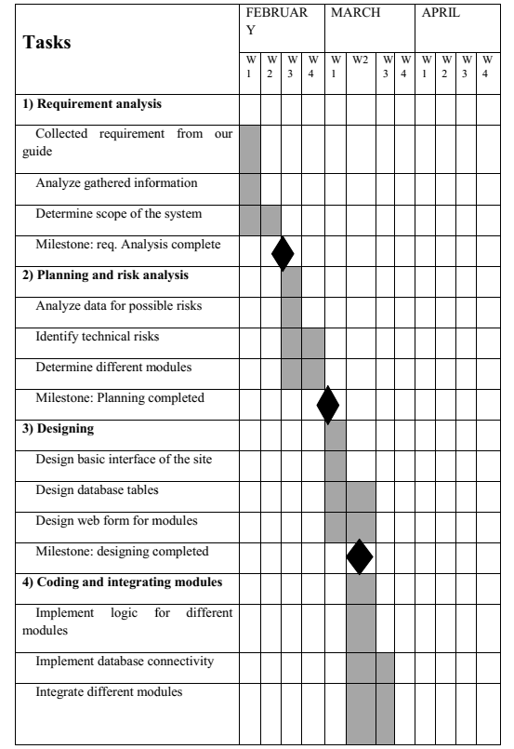**5.8 Time Line Chart**

